Absurdity of War
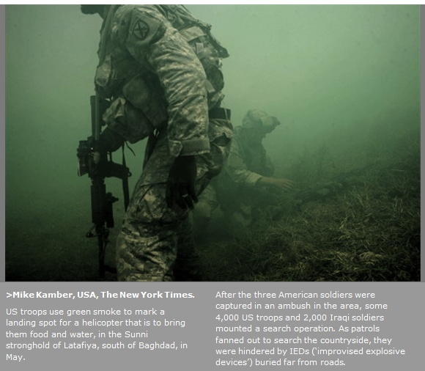
Haze.
Unnatural green.
Green haze of smoke.
Green smoke of death.
Everything’s blocked out, tainted by the hue of green. Everything looks unnatural. It’s funny how the color of nature, of the earth, can be twisted into something sinister. Mankind has caused death. Death of plants, wildlife, and people. The shriveled up grass curls up by the bottom right. The grass, spread every which way, may be green but it isn’t alive. It slowly withers away as a U.S. soldier squats next to them.
U.S. soldier.
A Soldier.
Generic.
The badge is noticeable on the soldier’s arm – an “x”. An “x” just like a checkmark in a list. With the flip of a pen, a signature on the dotted line next to the “x,” you can send a young man off to war. Those who willingly joining the army or those forced to it, it doesn’t matter. They’re all the same. In the end there are no different personalities, no character, and no humanity. Everyone is the same, none are innocent. From the hands of the conqueror to those of the vanquished, all are to blame. It seems fitting not knowing. Not knowing if the man in the foreground of the photo was the conqueror or the vanquished. If he willingly joined or was forced into the army. It’s only right that there is no face shown. No face, no name, no history, no guilt. No guilt, no shame in knowing or not knowing.
Black.
Sharp Edge.
Dark and Cold.
The cold steel of a gun.
The sharp edges of the standard M-16 issued submachine gun are clearly visible. Out of the haziness of the smoke the gun prevails. It is clear as day. Clear as night might be the better analogy. Gun is power and power is law. Without the gun there’d be no power to maintain law and order. Words written with ink on paper can only do so much before the cold steel of the gun is needed. But the gun can backfired. It could be used for evil, great evil, in the hands of oppressors. No one is immune to the blast of the gun. Better watch where you point that gun. The gun is pointed downwards towards the ground. Shooting Mother Nature at point blank.
Out of uncertainty.
In vagueness.
Hope.
There is a soldier in the background, the green pattern of his uniform blending with the green smoke. He squats down and touches the dead earth. There appears to be sympathy, understanding, and redemption. His head is also facing downward, just like the gun. But he calls for the earth, rather than merely using it to help him get up on his feet like the soldier in the foreground. He seems to maybe understand the ridiculousness of the situation. It’s possible he feels the pain the earth, the dying grass, the dying planet, and the dying race. Maybe it is also befitting that his face is also not shown. His face is not known, without any history. No face, no name, no history, no one to thank.
Bent.
Squatting down.
Weight of a nation.
Weight of the world.
Even though they’re both soldiers by profession, war is not their jobs. The soldier in the foreground is bent, carrying the pressure of an entire nation. The green smoke meant to aid, the constant assurances by his superiors, is not enough. His gun may be pointed down, but his stance is one of caution. Even the blanket of green smoke, a sign by the military showing the landing spot for a helicopter carrying aid, is not enough to make him forget he is in a war. The soldier in the background is bent, as if tending to a garden. Tending means growing and giving life a chance.
Another way to look at it.
A misunderstanding.
Sanctity.
It can’t be all bad. There has to be hope for some decency. The soldiers both had lives before they were sent off to war. The soldier in the foreground has a ring. A wedding ring. The ring shines brightly compared to the hazy darkness of everything else. Even though he is in war, he has not forgotten his values. He keeps his left hand, the hand with the ring, off the gun. He uses his right hand for the gun. Keeping your profession separate from your private life.
Haze.
Unnatural Green.
Green Smoke of Death.
Great Opportunities within.
There is so much pain in the world, so much suffering. Why can’t it just stop? End the wars, stop the fighting. Quit being controlled and stop mindlessly following order. Break out and don’t be afraid of letting in a little chaos in your life. How much is enough before we decide to try something new? Let’s lift up the veil covering our eyes, the smog choking us. Lets stop the fighting and go back home, to our wives, our children, our kids, our families. We have problems back at home that can’t be fix with a gun. Lets give a name to everyone out there and step out of the darkness, out of the shadows, of the smoke. Lets clear everything up.

