Kate McGuinnis
October 8, 2008
Intro Picture Essay
696 words

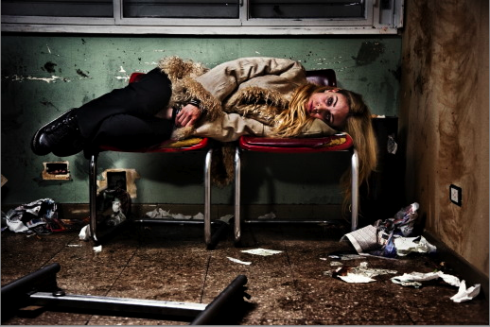

Double Take

A picture is truly worth a thousand words. It not only portrays a scene, but it shows emotion, while telling a story. Every little detail in a photo is there for a reason, giving one deeper insight into what is happening. You know the picture is more than just a picture when you get a sensation inside that makes you want to know more. Your imagination starts to run wild. The picture I have chosen is one that especially caught my eye. I couldn’t seem to pull my eyes away; I just kept looking. At first I noticed the room and the girl lying sideways on two beat up chairs. I noticed her facial expression and the clothing she is wearing. It gave me a sense of what she was thinking and what was going on around her. Details such as color, lighting, positioning, emotion, and even the way she has her hands in between her legs drew me in and left me wanting to know more.
Looking in from the outside we see this picture portraying the harsh realities of life, but look from the inside out it’s all just an act. Everything appears to be dirty and beat up: the chairs are torn, there are markings and holes in the walls, and the floor is covered in trash. The girl’s clothing is dark and ratty, helping her to blend in to the backround. The browns, blacks, and cool gray green wall give the sense that the place is cold; not just in temperature but that it’s not welcoming nor safe. Her baggy eyes covered in leftover smeared black liner give the sense that she has been crying and upset. The dark colored windows and dampened floor, as well as her large black boots and oversized dated coat give the sense that it is a cold winter night, and she has other things to worry about beside how she looks. The bright white light against the dull colored room adds to the harshness of the room exposing not only how truly dirty and beat up everything is, but also exposing the girl’s tense but saddened face.
The girl’s dark eyes and sleepless face give the sense that she is struggling. She looks as if she doesn’t know where else to turn too. From further away her eyes appear to be harsh and strong because of the dark eyeliner, but when taking a closer look they seem weak, lost and helpless. The way that she is curled up with her hand in between her legs shows she is trying to find a way to comfort herself. It’s almost as if her surroundings are symbolizing her inner feelings. The room and chairs once use to be new and clean and comforting, but overtime with more wear and use they have become dull and dirty and worn.
The picture is almost an illusion, in the sense that it tricks you into believing the situation. All that appears to be real is, in actuality, fake. From our perspective we see a girl suffering to make it in the world, waiting for something to come along, something to guide her in the right direction. From the actress’s perspective, yes she is waiting, but for the director to say cut, next scene, or that’s a rap. This photo portrays two views, one being the reality of the picture and the fact that it is just a movie set, and the second being that her character is real and waiting for something deeper than just the director’s cues.
A photo captures a moment in time; one single snapshot of a second in life that can never be repeated. However, this picture is an exception. It may appear to be a moment in time, but in reality it is staged. The ideas portrayed in this photo are purposely set up to be repeated and re-shot until perfect. In life these kind of experiences aren’t perfect and that’s what makes them real. At first glance we see one story, but take another look and you’ll see that it’s nothing but a fake.

