KEEPING YOUR TEAM ACCOUNTS

This is the instructions of how to keep your accounts for all of the buying at the auction and the selling via Ebay and the Car Boot sale.

The template is made up of three pages:

- A summary page which automatically updates totals as you insert entries into the other pages.

- A ‘Receipts’ page where you record amounts you have received from your Ebay Auctions and the Boot Sale.

- An ‘Expenses’ page where you record any amounts you have paid for stock, postage, fees etc.

Bring down a copy of the Enterprise Accounts file and save it adding your team name to the title.
Follow the commented worked example which is contained in the next three pages of this document, firstly to customise it with your team name etc. and then to enter your transactions . All of the instructions are shown inside the blue arrows .

Your lecturer will provide you with some of the figures as they become available.
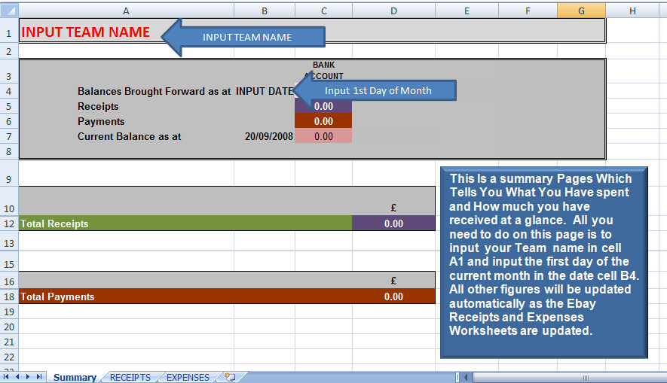
SUMMARY SHEET

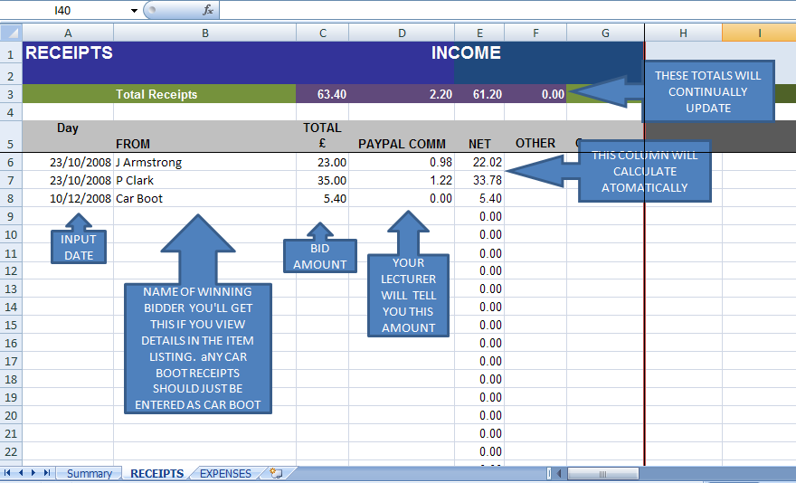
RECEIPTS

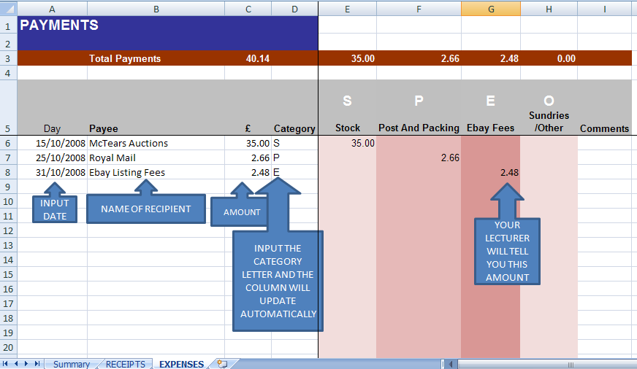
EXPENSES

