Seth Perlman
10/8/08
Photo Essay Assignment
Word Count: 587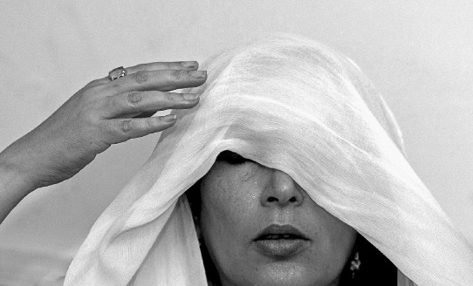
This picture of former Pakistani Prime Minister Benazir Bhutto conveys messages about her nation and Bhutto. The image speaks both to the conflict between Islam and secularism in Pakistan and also to the strength of character Bhutto required to bridge the gap between the two worlds.
Bhutto is depicted lifting the veil off of her face, which is moist with sweat. This gives us the feeling that she has to work very hard to lift the veil. It is not as simple a task as it appears on the surface. The surprising complexity of the task adds to the sense that the picture represents a deeper metaphor.
Despite the difficulty of raising the veil – that is, breaking free of Islamic restraints on her political ambitions – the set of Bhutto’s jaw and mouth shows she has lifted it many times before. She appears confident and unsurprised. Significantly, Bhutto does not take off the veil; she just pushes it back again. The struggle against the veil is a constant; it cannot be removed permanently, nor can it be allowed to hide her permanently. The covered/uncovered cycle is eternal.
The key relationship in the picture is the connection between Bhutto and her veil. Pakistan is currently in a time of upheaval. The hard-line of religion is bumping up against secularism. As a female world-leader, Bhutto represented progress and separation from a fundamentalist Islamic state. In contrast, the veil, Islamic ceremonial clothing intended to hide the female form, represents the hold of Islam. By viewing the image with these symbols in mind, the picture is commenting on not just Bhutto herself, but on Pakistan’s greater struggle with the separation of Church and State. In the image, Bhutto is pulling back the veil of religion from her eyes. Religion is blinding her. That said, she is not removing it entirely. Therefore, she is not trying to remove all religion from the government; she is just trying to stop it from being a barrier to political peace.
One of the most jarring facets of the picture is the way in which Bhutto’s hand appears disembodied. It is coming in at an awkward angle. Therefore, the hand may represent not just her own efforts, but also the hand of justice or political change. The hand is reaching in from the outside world to help her remove the blinding veil of religion. Finally, the hand gives the impression that it is just about to touch Bhutto. It is so close to completing its goal.
As she pushes the veil farther back, more and more light reaches her face. If the veil is just pushed back a little further, the light will reach her eyes. Also, the area under the veil is very dark. Bhutto is emerging from the darkness into the light.
The omnipresent, blinding white of the picture causes the viewer to freeze. Bhutto is emerging like an angel, a more powerful image in light of her recent death. Like ice, the picture conveys a sense that everything has just stopped. Connecting back to the metaphor, it appears as if the world is holding its breath, waiting to see if Bhutto will be able to succeed in pushing back the veil of Islam. Unfortunately, Bhutto was assassinated just two months after this picture was taken. Her death gives this picture its most powerful message. So close to success, Bhutto was slain, and any near-term prospects for progress in Pakistan were slain with her. The world froze.

