Emmanuel Lifschultz
Writer’s Workshop – Lombardo
543 words
The Inevitable Fate of the Tusked Lord of the Icy Waters
The narwhal is a very majestic creature, one that shows the magic, mystery, and creativity in nature. With such a powerful yet peaceful and graceful composure, this horned beauty wades through the icy waters. In harmony with its surroundings, being able to dive to unimaginable depths, this powerful giant knows its in control of its cold icy domain. You would think the narwhal would stay in its comfort zone, but an innate irresistible urge necessitates the adamant inevitable breach into the world above the surface. The narwhal, being a mammal, needs to breath air, and, thus, has to surface every so often to refill its lungs. It is during these moments that the outside forces plan to carry out their attack. With lethal force, the narwhal is hunted and stalked to potentially bring it to a brutal fatality.
The Inuit people of former days would hunt the narwhals only to provide for their families. The narwhals were killed only when necessary, and there was balance even within such a savage act. Unfortunately, this balance could not last forever, and as if destined to be, the onslaught of narwhals began. Due to recent technological advances, the Inuit people now use guns to hunt narwhals, resulting in extra narwhal deaths. The naturally necessitated balance between man and narwhal has been decimated. The extra deaths of narwhals due to gunshots have been determined to be from thirty to seventy percent. Many of these marvelous creatures are mercilessly slaughtered and apathetically skinned and decapitated, as their guts lay strewn over the crimson stained ice. Without remorse or so much as a shudder of sentiment, they are robbed of their glorious horn and treated with icy cold impassivity. The decapitated head of the once alive and beautiful narwhal still seems to retain its regality. With the head slightly tilted up facing the sky and its massive tusk protruding upwards in a stately fashion, it makes it seem as if it’s accepting its present fate and moving on looking forward and up.
The orientation of the head and the tusk being at key points in the photo that draw your eye, makes you look at the head and then it to the ivory white tip of its tusk, further implementing its regality and acceptance of its fate. Throughout the photo, the intrusive feel of the red evokes a response in the person looking at the photo, especially with the red again the mellow less vibrant hues of blue with slight tints of green in the water and the seemingly soft white of the ice. The red truly does seem to be out of place in the photo. The head of the narwhal also seems out of place being off center in the photo and because it’s a random narwhal head without signs of much else for a vast distance. The canals in the ice also seem out of place. All three of these things are results of human interference.
Looking at the photo, there are harsh contrasts in color and sharp clear distinctions made among separate objects. This photo is a very loud bold photo that gets its point across with strong brevity.

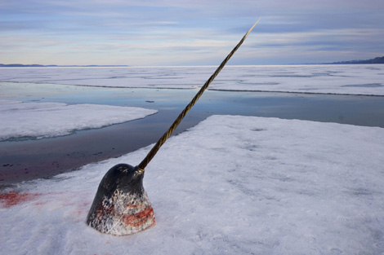
Caption: Paul Nicklen, Canada, National Geographic Magazine.
The head of a male narwhal stands on the ice, waiting for hunters to remove its tusk. Tusks of the narwhal whale were once sold as unicorn horns, and were immensely valuable. Today, narwhal ivory can still fetch large sums, and the whales are legally hunted by some Inuit groups. Hunters shoot the whales for their ivory, skin and blubber, but much of the meat goes to waste.

