Enterprise Activity 1
The following six items were presented at McTears Auction for the sale of 13-Sep-2008 by one of the specialist tutors. Each group of students have to conduct research into the six catalogue entries below and record your findings on the group blog.
The first lot catalogue entry is :-
560 | 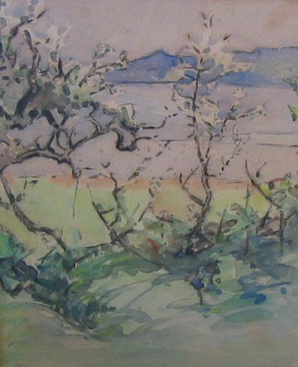  Anna Mary Hotchkins (1885-1974)  View of the Coastline (China?) Through Prunus  watercolour, signed  30.5cm x 24cm  Note: Studied at Glasgow School of Art from 1906-1910, in Munich and at Edinburgh College of Art under Robert Burns. She lived in China 1926-37, taught at the Yenching University, Peking (1922-4). She met an American artist Mary Mulliken and the two women travelled widely to very remote parts of China. She painted in watercolour and oil, often working alongside Dorothy Johnstone, May Brown, Cecile Walton and Jessie King in Kirkcudbright  (Unsold)
This catalogue entry contains an error in the name of the artist. Task 1 is to determine her correct name.
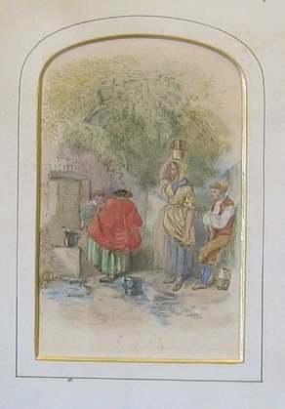
561 | Myles Birket Foster (attrib.) (1825-1899)  Figures Gathering Round a Well  watercolour, signed indistinctly verso Birket Foster  13.3cm x 8.5cm  Sold for £27

Task 2 is to determine how this artist normally signs his work.

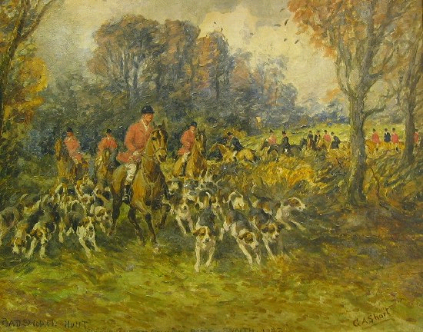
562 George Anderson Short (1856-1945)
entitled 'Badsworth Hunt coming out at Cowick Park, Snaith 1922'
oil on board
37cm x 47.5cm
Sold for £260

Task 3 is to determine if Badsworth Hunt is still in existence.

563 | After George Henry Hall (American 1825-1913)  oileographs, a pair, signed and dated 1860 and titled Sevilla  59cm x 39cm (Unsold)  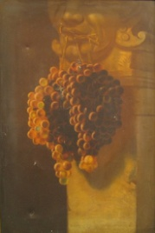  Task 4 is to estimate the value of these oileographs if they were in fact oil paintings
564 A. J. Miller (Alfred Jacob Miller?) Woman at
style oil on paper laid on board (23cm x 16cm)
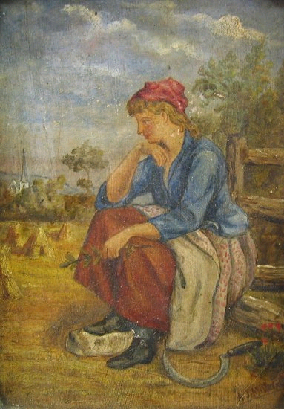

Task 5 is to determine what subjects Alfred Jacob Miller normally paints and why this painting is unlikely to be by him.
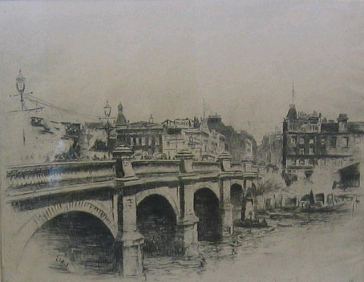
565 Thomas Paterson
Jamaica Street Bridge, Glasgow
etching
21cm x 25.5cm
Sold for £15

Task 6 is to describe what an etching is.

