Perri Mayer
October 7, 2008
Photo Essay Assignment
0 Words

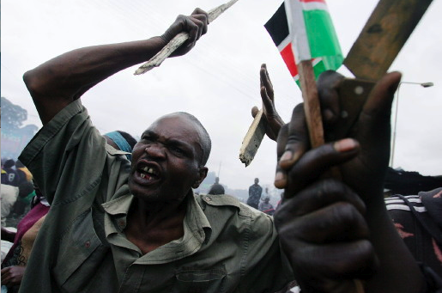

It is incredible how much emotion can come from just one picture. This is a photograph of a political protest in Kibera, Nairobi, taken by Roberto Schmidt. The previous president was defeated, and when the new president was put into office, riots broke out throughout the city. It is obvious that this scene is one of chaos and anger. By looking at this photo, you can almost imagine what it would be like to be at this protest, engulfed by enraged, screaming mobs. This photo represents both the anger and the uncertainty of this protest.
There are many things going on in this photo. The first thing noticed is the man in the central focus of the frame. This man is furious. His collar bone is popping out as if he is screaming, his brow is furrowed, he has a huge vein showing through his bald head, and lastly, he is gripping a wooden stake with all his strength. This man represents the anger of the protest. He is just one of the many at this rally who is livid with the current political situation in Nairobi.
The next thing noticed in this photo is the hand behind the central focus. It is also holding a stake, but differently than the man in front of him. This person is holding the stake in the crook between his thumb and his forefinger, with the rest of his fingers outstretched. The man gripping the stake seems much more passionate and violent than this person. This person seems a bit uncertain on his emotion. Yes, it is still violent, but it doesn’t give a strong influence. Maybe this person is confused, or maybe he is just allowing his tired hands a break. Either way, even though we cannot see his facial expressions, his hand gestures show a much more relaxed form of violence, unlike the man in front of him.
Both the third and fourth things I notice are intertwined, as are the hands holding them. In the lower corner of the photo, there are two separate hands- one holding a kitchen knife and one holding a flag. A few fingers from the hand holding the knife are touching the hand holding the flag. This represents uncertainty. It seems that both hands want what the other one is holding. The hand with the knife, representing violence, may want what the flag has, hope and patriotism, and vise versa. Another thing I noticed was the stillness of the background. Looking beyond the main focus, you notice some people just observing. They seem like guards, since they are wearing camouflage and have their hands behind their backs. However, they also seem uncertain. If there were a huge riot going on, wouldn’t the guards want to take control? They are uncertain what to do, how to approach these crowds, etc. The uncertainty of the guards corresponds with some of the uncertainty in the main focus, such as the knife, the open hand held stake, and the flag.
Schmidt captures both violence and uncertainty in this photo. There are some aspects, such as the screaming man in the central focus, which obviously portray violence and anger. On the other hand, the flag, the knife, the guards and the stake all depict uncertainty. In just one photograph, one moment of time, you can almost imagine being there, hearing the screams and living the violence.

