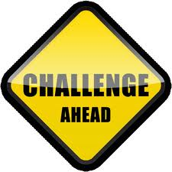

Welcome to Challenge based learning!

I’m glad that all of you decided to take this course and look forward to working with each and every one of you. This purpose of this course is to create challenge based learning units of study. Psychological research and theory suggests that by having students learn through experience of solving problems, they can both learn both content and thinking strategies.(Hmelo-Silver, 2004)

The Theory of Independent Study-Charles Wedemeyer is what this course is based upon. Wedemeyer felt that there were ten characteristics that emphasized learner independence and adoption of technology as a way to implement that independence. (Simonson, 2012) Not only will the students in this class use the theory of independent study, the people who develop the challenge-based learning will employ many of the same characteristics when creating their final products.

To begin the course student’s will view a video presentation of a challenge based learning project. Once the video of the completed project is viewed the students will backwards plan to see how the project began. The students will look at the storyboard for the finished product, to see where the ideas started. The key piece to challenge-based learning is to find a problem in the world today.

Storyboard:

For a digital object to be effective in an online course, it must be relevant to the course content, and must materially contribute to the achievement of outcomes.(Nash,2005) The use of a digital storyboard will be effective in letting everyone know your vision, and see where you are going with your project without going into extensive detail.
storyboarding helps you:
- Define the parameters of a story within available resources and time
- Organize and focus a story
- Figure out what medium to use for each part of the story

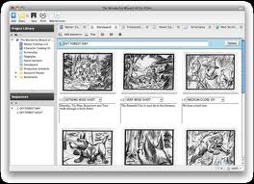

How to Do a Rough Storyboard
A multimedia story is some combination of video, text, still photos, audio, graphics and interactivity presented in a nonlinear format in which the information in each medium is complementary, not redundant. So your storyboard should be put together with all those elements in mind.
The first thing to tackle is the part about the story being nonlinear.
1. Divide the story into its logical, nonlinear parts, such as:
- a lead or nut paragraph, essentially addressing why this story is important
- profiles of the main person or people in the story
- the event or situation
- any process or how something works
- pros and cons
- the history of the event or situation
other related issues raised by the story
I would have the teachers develop and follow a storyboard to plan out their initial plans. When setting up a storyboard, it can help ensure there are pieces that are not left out. It is a great way to simply draw out and organize your information. There are virtually many different ways to storyboard. Students will backwards plan once they have decided on their problem they want their challenge to find a solution to. If you start with the end result, it is much easier to see what you need to do to get there.
Students will be expected to view various training videos, through streaming video, provide feedback and discussion points to others. They will set up a blog in order to be able to communicate with their peers and post feedback. All students will have to subscribe to the classes’ blogs and be responsible for providing weekly feedback on the progress of their peers project.

Blogs:
A blog is often a mixture of what is happening in a person's life and what is happening on the Web, a kind of hybrid diary/guide site, although there are as many unique types of blogs as there are people.
The purpose of the Blog is to keep everyone in the class and everyone interested in what’s happening up to date. Michael Moore believes a key piece of distance education is two way communication.(Simonson, 2012) By using blogs in this course it allows for the students and teacher to keep a two way communication open. It also allows for students with varying time constraints to be able to communicate effectively in a timely manner.
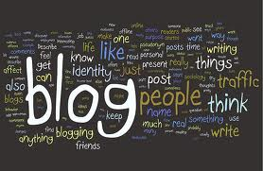
Weblogs: Weblogs, or "blogs," constitute informal repositories of learning objects in two ways. First, the "blog roll," or list of related or recommended blogs helps one become acquainted with other blogs. The blogs in the blogroll can, in fact, be considered learning objects when utilized for an educational purpose. Aggregators of blogs that bring together excerpts of posts from blogs by means of syndication (RSS) also could be considered informal repositories of learning objects.(Nash, 2005)

References:

Hmelo-Silver, C (2004). Problem-Based Learning: What and How do Students Learn? Educational Psychology Review, Vol 16, No. 3, September 2004

R Smith Nash, S. (2005). Learning objects, learning object repositories, and learning theory: preliminary best practices for online courses. Interdisciplinary Journal of Knowledge and Learning Objects, 1. Retrieved from http://www.ijello.org/Volume1/v1p217-228Nash.pdf

Simonson, M., Smaldino, S., Albright, M., & Zvacek, S. (2012). Teaching and learning at a distance: Foundations of distance education (5th ed.) Boston, MA: Pearson.
Picture Credits:
Challenge Based Learning Resources
esu8.org

Er-blog-why-get-them-blogging. Image: Kristina B
jasonrenshaw.typepad.com

I don't storyboard. I do, however, firmly believe that it will save you ...
instructables.com

