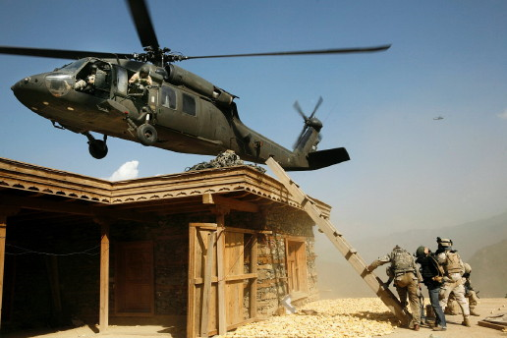

In this photograph by Tim Hetherington, we can see a helicopter picking up an American commander from the recently bombed village of Yaka China. The triangle between the house, humans, and helicopter is the most prominent symbol and easily recognizable. This triangle plays an important part in leading the viewer into the overall theme of the piece, which is the transition between ground and sky. This theme is further emphasized by the placement of colors and materials in the picture, and symbols such as the ladder. This transition, however, is not the only theme of the picture. There are many minor details, and stories that can be seen by this photo.
The story of this picture can be discerned by merely looking at the people in it. The gunman on the helicopter is poised and ready for action, implying that they are in a dangerous situation. The soldiers on the ground, escorting an unknown civilian are moving to go up the ladder, as one of them kneels to provide more cover fire. This situation best represents an escape or withdrawal from dangerous territory. Another thing to be noticed is the helicopter in the distance. It is a similar helicopter, over similar mountains, which suggests that situations like this one are happening all over.
The main theme of this piece, movement from bottom to top, can be seen going from the stable ground, into the moving sky. The house is still and unmoving, attracted to the ground. The soldiers, on the other hand, are in motion, as one begins to climb the ladder and all the rest prepare. The helicopter, whose edges leave the piece, making it open composition, indicates extreme motion. Blur of the blades shows us that the helicopter is moving at high speeds, and capable of great movement. In addition, the elements of the objects in the picture make a difference in their motion. The house, made out of wood and stone, natural elements found on Earth, doesn’t move. On the other hand, the soldiers, their gear, and the army-crafted helicopter, are made out of a large composition of materials, many of which are man-made, and not bound to the Earth.
The motion from bottom to top in this piece is not the only indication of the transition. Dirt and dust in the right side of the picture illustrates this by changing colors. On the bottom is a light brown, which slowly turns into a lighter, whiter color as the dust approaches the top of the house. After passing the roof we can see elements of blue being integrated, turning it into a light blue color, which then changes to a darker and darker blue until it reaches the dark blue sky, found at the top of the picture.
A prominent symbol of the transition between earth and sky can be seen by the ladder set up against the house. Not only are ladders used for climbing upwards, but this ladder in particular shows the viewer more. In the picture, the ladder’s base is at the feet of the soldiers, and the end is located in the green of the helicopter. This reinforces that not only are things moving upward, but specifically that the soldiers are moving upward to the helicopter.
Another thing we must consider is the layout of the piece. The first area of the piece is the ground at the bottom of the picture. It contains a house, a ladder, soldiers and rocks. In the photograph there is nothing above this location, and mountains below it. It seems to be the highest point, but it is, however, enclosed and stuck to the Earth. The sky, on the other hand, where the helicopters are located, is open and free. All we can see is the two helicopters, and the difference in size indicates the difference in distance. It is not cluttered with too many objects nor lacking in space, which relates to the natural tendency of moving from a highly concentrated area, to a lesser one.
This photo leaves the viewer with a clear view of the transition from earth to sky, but does not expand as much on the story of the photo. It is clear that the soldiers and civilian must leave quickly, but it is unknown as to why, or for what purpose the civilian was brought along. The presence of the Blackhawk helicopter indicates an obvious military presence, but who are the soldiers fighting? In the end, we can only assess the situation from what we see, and we must assume that the photographer regards these questions as unimportant as he chooses to focus on the elements already discussed.

