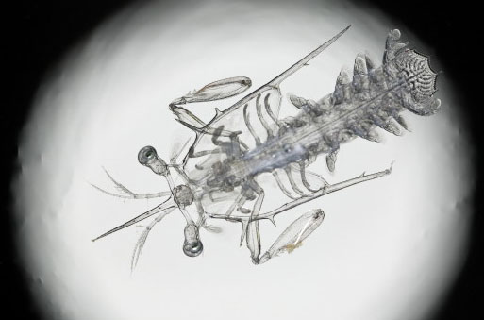

There are so many aspects of nature to be explored, some of which can only be seen with the help of science. This photograph gives us a deeper look into nature, magnifying a creature so it can be seen with the human eye. This photo is a mantis shrimp larva under a microscope, invisible to the eye, except for the helpful shadows on its form. The sight of this creature can only be obtained by the use of a microscope, because it is so small – the size of a shrimp larva (baby shrimp) is basically only a few centimeters. Through the microscope, secrets unfold. The viewer is able to examine the details of the shrimp: the structural anatomy, invisibility, et cetera. The creature, suspicious of no longer being hidden, freezes in place. It does not move; the shrimp larva’s transparent body stays in the same place. It is almost as if the shrimp is prey – it tries to conceal itself from potential predators – perhaps the one looking through the microscope.
This photograph illustrates many aspects of a predator and prey relationship. This shrimp larva is intimidating as a predator because it has so many “extra” legs and antennae. These extra body parts are used, however, for defense. If a predator of shrimp sees this larva, it might not attack the shrimp because it looks abnormal – this saves the shrimp larva, if only for period of time. Another strong defense mechanism of this shrimp is its invisibility. The shrimp could use its transparency in two ways: one, to hide from potential predators, and two, when the shrimp larva develops into an adult, it will have the ability to sneak up on its prey, concealing itself within the water.
The anatomy of the shrimp is cleverly outlined by the high contrast of the photograph. The black and white levels of contrast allow the viewer to clearly define what the creature has. It is also a good technique, because the shrimp is toned in a light gray, assuming the photographer did not desaturate (take the color from) the image. This makes the shrimp the object of attention, and some viewers may not be able to even recognize that the photo was taken in a microscope. Since the mantis shrimp is an underwater creature, some viewers may wonder why it is not in water.
This focus on the shrimp brings yet another thought to the viewer’s mind: is this creature real? And if it is, is it dead or alive? It is hard to tell from a microscopic photograph, but this creature is indeed real. Although as mentioned before, the photo was not taken in water, and this soon-to-be massive and aggressive type of shrimp is only frozen in place due to fright. Alas, it might not even be true fright; the tactics a mantis shrimp uses to capture its prey are often secretive. The mantis shrimp like to sneak up on their prey – when in the water, their many legs make it easy for the mantis shrimp to move quickly and stealthily. Then the shrimp uses its maxillipeds (side limbs) to attack its prey. They can cause severe injuries, and in some cases, when the mantis shrimp are in contact with humans, their attacks result in the requirement of stitches (shrimpers and divers call them “thumb splitters). The speed at which the mantis shrimp can ‘strike out’ at is over twenty miles per second, making it a very powerful predator and defensive creature.
The mantis shrimp larva in this photograph not only resembles the remarkable structure of nature, but also demonstrates the intricate actions that science would allow for this creature. The transparency, anatomy and form of the shrimp represent nature. The frame, contrast, and clarity of the subject in the photograph gives the viewer a more scientific view on an “ordinary” creature.

